FREE
Enjoy an evening of music and refreshments
at
[ Name ] Coffeehouse
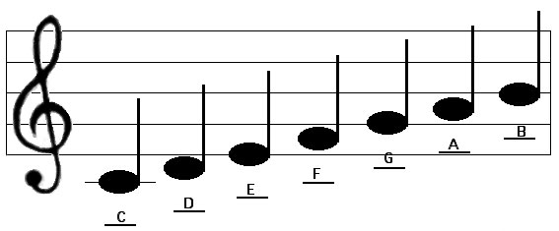

Join the fun every [ Friday ] night at [7:00 ] PM

Always FREE…

Always Fun…

Bring a Friend!

[ Street Address ]
[ City ], [ State ] [ Zip ]
Call [ Name ] for details [Phone # ]
In association with
www.NewEnglandChristianCoffeehouses.com

